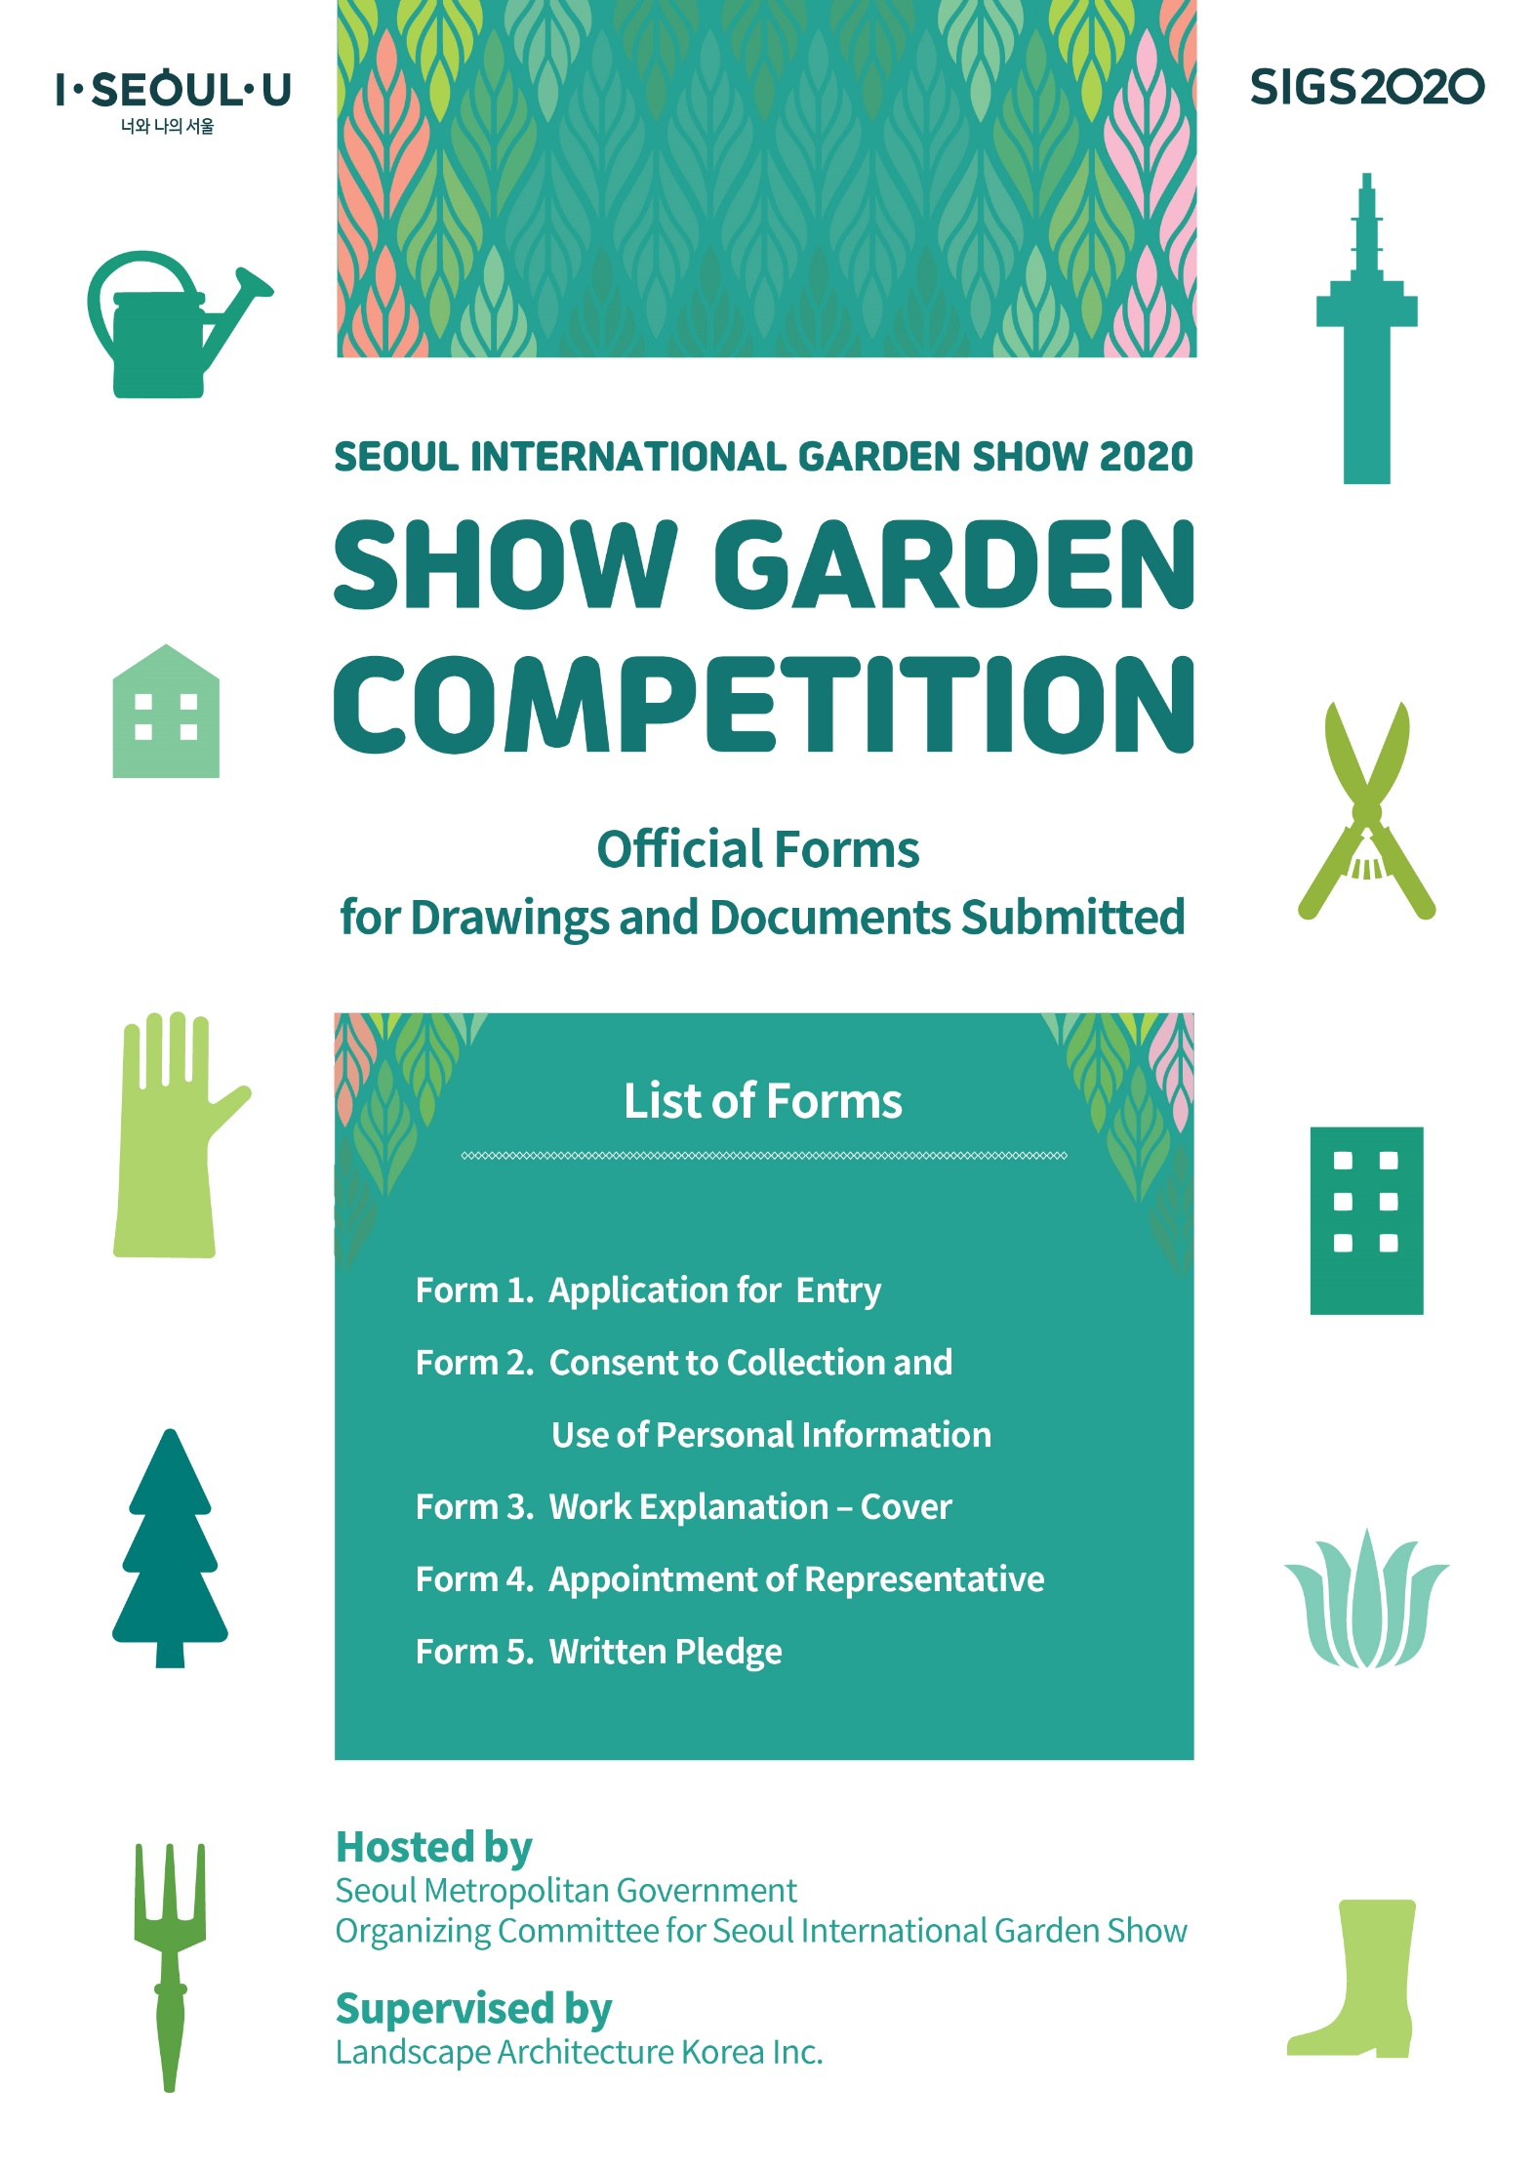[Attachment]

Form 1

|  |  |  |  |  |  |  |  |  |
| --- | --- | --- | --- | --- | --- | --- | --- | --- |
| **Application for Entry: Show Garden Competition** | | | | | | | | |
| Category | Show Gardens | | | | | | | |
| Entry No. | ※ Not to be filled out | | | | | | | |
| Title of Work |  | | | | | | | |
| Personal Information of Applicants | Name of Representative |  | | | Name of  Co-applicant |  | | |
| Birth Date |  | | | Birth Date |  | | |
| Phone |  | | | Phone |  | | |
| E-mail |  | | | E-mail |  | | |
| Address |  | | | Address |  | | |
| Occupation |  | | | Occupation |  | | |
| Academic Career | Period | | Name of Institute | | | Major | |
|  | |  | | |  | |
|  | |  | | |  | |
|  | |  | | |  | |
| Major Activities | Period | Activities | | | | | Organization and Location |
|  |  | | | | |  |
|  |  | | | | |  |
|  |  | | | | |  |
|  |  | | | | |  |
| Attachment: ①A2 Panel: 1 ②Work explanation: 1 ③Consent to collection and use of personal information: 1 | | | | | | | | |
| I (and my team) hereby apply for Show Gardens of Seoul International Garden Show 2020, accepting the regulations of the competition.  Date: (dd/mm/yy)  Applicant: (signature) (representative) | | | | | | | | |
| ◆ Notice  - Show gardens will be constructed and maintained in the site, and the selected designs of the gardens can be modified after consultations according to the conditions of the site.  - The number of the selected works(applicants) can be changed based on the outcomes of the review and screening.  - If there should be any false information or significant imperfections on the submitted documents, if a submitted work is not original or a result of plagiarism, or it is either the same as or similar to the works previously submitted to other competitions, or if it infringes the copyrights of others, the work will be excluded from review and screening, and when any violations of the regulations are discovered, awards will be cancelled and prize money will have to be returned.  - Other matters are subject to the competition guidelines.  ◆ For further information: Landscape Architecture Korea Inc. (e-mail: klam@chol.com) | | | | | | | | |

Form 2

|  |
| --- |
| **Consent to Collection and Use of Personal Information**  **1. Purpose of Collection/Use**  Selecting the teams to participate in 「Show Garden Competition of Seoul International Garden Show 2020」 and collecting and using personal information necessary for relevant work including database establishment.  **2. Items to Be Collected**  a. General information - name, birth date, address, etc.  b. Social information – professional experience, certification, etc.  c. Contact information – e-mail address, mobile phone number, etc.  d. Miscellaneous information – team introduction, idea proposal, etc.  **3. Retention/Use Period**  From the date the applicant agrees and for the document retention period of the Seoul Metropolitan Government.  Under 「Personal Information Protection Act」 and its enforcement ordinance and regulation, I agree to the collection/use of my personal information I have provided for the aforementioned purpose and period.  Date: (dd/mm/yy)  Applicant: (signature) |

Form 3

|  |  |  |  |  |  |  |  |  |
| --- | --- | --- | --- | --- | --- | --- | --- | --- |
| |  |  | | --- | --- | | Review  No. |  |  |  |  |  | | --- | --- | --- | | Show Garden Competition |  | **Work Explanation** | |  | |  |  |  | | --- | | Title of Work |   , , 2020  Recipient: Landscape Architecture Korea Inc. |

Form 4

|  |
| --- |
| **Appointment of Representative**  **Title of Competition:**  **Show Garden Competition of Seoul International Garden Show 2020**  **Appointment of Representative**  ① Organization:  ② Name:  The above person is appointed as the representative under the agreement of all co-applicants and is delegated all powers for the above competition held by the Seoul Metropolitan Government.    Date: (dd/mm/yy)  Co-applicant: (signature)  Co-applicant: (signature) |

|  |
| --- |
| **Written Pledge**  I (my team), sincerely swear that in applying for the “Show Garden Competition of Seoul International Garden Show 2020” conducted by the Seoul Metropolitan Government, will faithfully comply with the competition regulations and guidelines, and prepare and submit documents and related supporting materials in accordance with the principles of good faith, and accept any disadvantages if the submitted materials have been prepared in an illegal way or if it should be discovered and confirmed that there is false information.  Date: (dd/mm/yy)  Representative: (signature) |

Form 5